**AUTOMATIC TRANSMISSION CONTROLLER**

**INTRODUCTION**

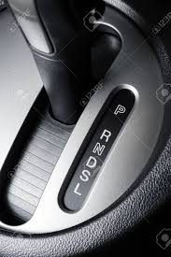The Transmission Control Module (TCM) controls modern automotive transmissions based on input from various sensors as well as data provided by engine control module (ECM). It processes this input to calculate how and when to shift gears in the transmission and generates the signals that drive actuators to accomplish this shifting. The software in the TCM is designed to optimize vehicle performance, shift quality and fuel efficiency.

The AT(Automatic Transmission) is also called Auto or Self-Shifting Transmission or AGS (Auto Gear Shift) is a type of gearbox which automatically changes gear ratios, it allows an internal combustion engine to provide speed and torque outputs necessary for the vehicle movement.

GEAR MODES:-

* **Park** (*P*): This position disengages the transmission from the engine (as per the Neutral position) and a [parking pawl](https://en.wikipedia.org/wiki/Parking_pawl) mechanically locks the output shaft of the transmission.

This prevents the driven wheels from rotating (although the non-driven wheels are still free to rotate) which typically prevents the vehicle from moving. The use of the [hand brake](https://en.wikipedia.org/wiki/Hand_brake) (*parking brake*) is also recommended when parking on slopes, since this provides greater protection from the vehicle moving.

The park position usually includes a lockout function (such as a button on the side of the gear selector or requiring that the brake pedal be pressed) which prevents the transmission from being accidentally shifted from Park into other gear selector positions.

* **Reverse** (*R*): This position engages reverse gear, so that the vehicle drives in a backwards direction. It also operates the reversing lights and on some vehicles can activate other functions including [parking sensors](https://en.wikipedia.org/wiki/Parking_sensor), [backup cameras](https://en.wikipedia.org/wiki/Backup_camera) and reversing beepers (to warn pedestrians).

Some modern transmissions have a mechanism that will prevent shifting into the Reverse position when the vehicle is moving forward, often using a switch on the brake pedal or electronic transmission controls that monitor the vehicle speed.

* **Neutral** (*N*): This position disengages the transmission from the engine, allowing the vehicle to move regardless of the engine's speed. Prolonged movement of the vehicle in Neutral with the engine off at significant speeds ("coasting") can damage some automatic transmissions, since the lubrication pump is often powered by the input side of the transmission and is therefore not running when the transmission is in Neutral.
* **Drive** (*D*): This position is the normal mode for driving forwards. It allows the transmission to engage the full range of available forward gear ratios.

EQUATIONS USED FOR MODELLING:-

**Equation 1**

$$I_{ei} \dot{N}_e = T_e -T_i $$

$$ N_e = \mbox{ engine speed (RPM)}$$

$$I_{ei} = \mbox{ moment of inertia of the engine and the impeller}$$

$$T_e, T_i = \mbox{ engine and impeller torque}$$

The input-output characteristics of the torque converter can be expressed as functions of the engine speed and the turbine speed.

**Equation 2**

$$T_i = \frac{N_e^2}{K^2}$$

$$K= f_2 \frac{N_{in}}{N_e} = \mbox{ K-factor (capacity)}$$

$$N_{in} = \mbox{ speed of turbine (torque converter output) = transmission input speed (RPM)}$$

$$R_{TQ} = f_3 \frac{N_{in}}{N_e} = \mbox{ torque ratio}$$

The transmission model is implemented via static gear ratios, assuming small shift times .

**Equation 3**

$$R_{TR} = f_4(gear) = \mbox{ transmission ratio}$$

$$T_{out} = R_{TR} T_{in}$$

$$N_{in} = R_{TR} N_{out}$$

$$T_{in}, T_{out} = \mbox{ transmission input and output torques}$$

$$N_{in}, N_{out} = \mbox{ transmission input and output speed (RPM)}$$

The final drive, inertia, and a dynamically varying load constitute the vehicle dynamics.

**Equation 4**

$$ I_v \dot{N}_w = R_{fd}(T_{out}-T_{load})$$

$$I_v = \mbox{ vehicle inertia}$$

$$N_w = \mbox{ wheel speed (RPM)}$$

$$R_{fd} = \mbox{ final drive ratio}$$

$$T_{load} = f_5(N_w) = \mbox{ load torque}$$

The load torque includes both the road load and brake torque. The road load is the sum of frictional and aerodynamic losses.

**Equation 5**

$$ T_{load} = sgn(mph) (R_{load0} + R_{load2} mph^2 + T_{brake}) $$

$$ R_{load0}, R_{load2} = \mbox{ friction and aerodynamic drag coefficients} $$

$$ T_{load}, T_{brake} = \mbox{ load and brake torques} $$

$$ mph = \mbox{ vehicle linear velocity}$$

**SYSTEM DESIGN:-**

1) ENGINE SUBSYSTEM

This system is created by using equation 1 where throttle input is given through accelerator pedal.

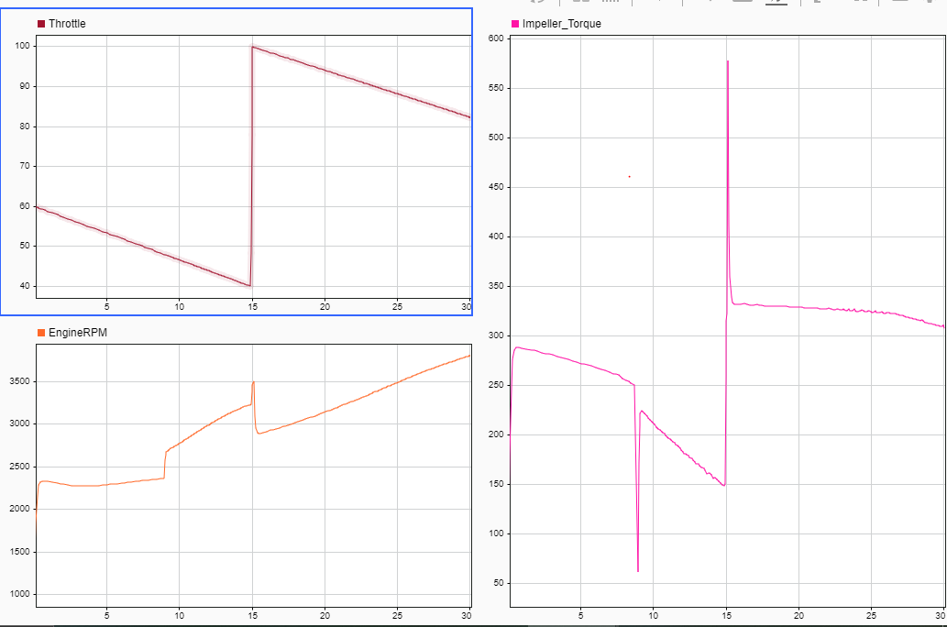

Data Inspector input & output of Engine System.

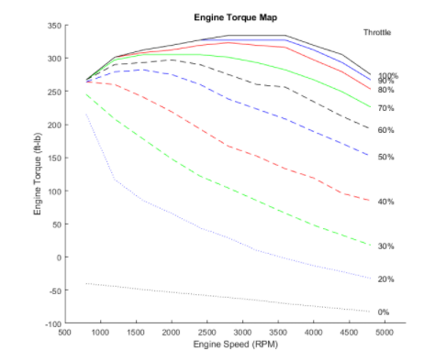

**2-D Look-Up Table** is used to compute engine torque based on the given graphical data.

2) SHIFT GEAR

State flow logic is built to inspect gears based on vehicle speed changes while driving vehicle based on the basic vehicle threshold of various gears for upshifting and downshifting.

The selection state (always active) begins by performing the computations indicated in its during function.

You can understand it’s working by example below.

For example, if the vehicle is moving along in third gear with 50% throttle, the state second is active within gear state, and SteadyState is active in the selection state. The during function of the latter, finds that an upshift should take place when the vehicle exceeds 50 mph. At the moment this becomes true, the model enters the upshifting state. While in this state, if the vehicle speed remains above 50 mph for 2 ticks, the model satisfies the transition condition leading down to the lower right junction. This also satisfies the condition [gear == 3] on the transition leading from here to SteadyState, so the model now takes the overall transition from upshifting to SteadyState and broadcasts the event UP as a transition action. Consequently, the transition from second to third is taken in gear state which completes the shift logic.

3) TRANSMISSION SUBSYSTEM

This system used to calculate output torque based on various changes in gear ratio.

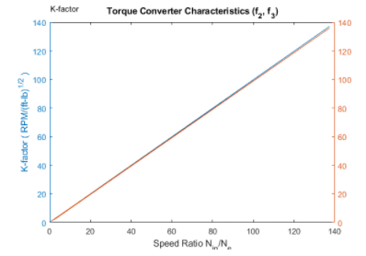So It used a Torque converter to converter Engine RPM speed to Impeller Torque which is a kind of mechanical torque.

Here we use **two 1-D lookup tables** to K-factor, torque ratio using speed ratio which is related to gear ratio according to equation 2.

4) VEHICLE SUBSYSTEM

So, Here we have created a generalized vehicle as a subsystem to study how the transmission happens over when vehicle is on road.

To specify the road characteristics we used a **Matlab Function.**

y=rload0+rload2\*u^2 where y=f(u)

rload0 and rload2 are vehicle data parameters for drag friction at wheels and aerodynamic drag respectively.

So equation 3, 4 and 5 is used to model the vehicle subsystem and vehicle speed , Transmission RPM is computed as the output.

Also the system has break input as null or zero here means no break is applied.

**SYSTEM INPUT**

This is given to system using the **signal builder block**.

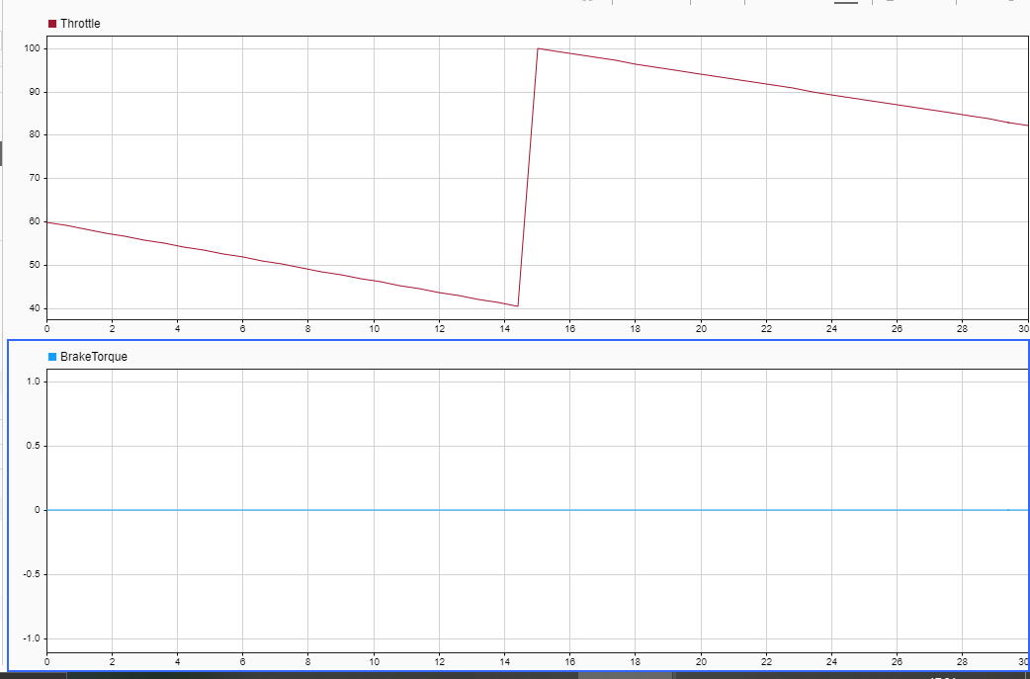

**SYSTEM OUTPUT(using data Inspector)**

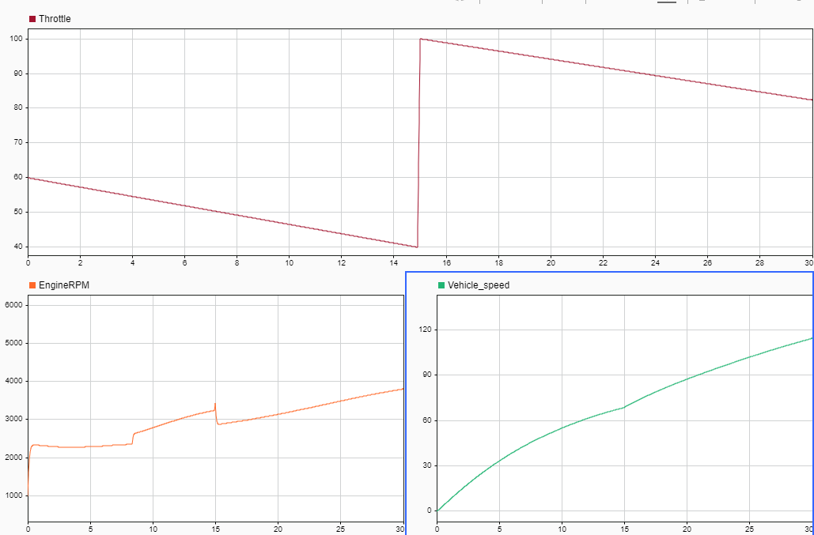

**SOLVER SELECTION STRATEGY**

Selected Solver is: - Fixed step ode5 (Dormand Prince)

Uses the fifth-order Dormand-Prince formula to compute the model state at the next time step as an explicit function of the current value of the state and the state derivatives approximated at intermediate points.

I used Fixed-step solver because it solves the model at regular time intervals from the beginning to the end of the simulation. Generally, a smaller the step size increases the accuracy of the results but also increases the time required to simulate the system.

Ode5 is general solver that solves the equation using mathematical calculation which is a faster way to compute anything but I have used it because it provides the desired output without distorting any system conditions. We can use ode45 also but it uses a variable step solver which is not preferable here to get the desired output and due to its complexity handling capacity. Here we’re getting quite accurate results with ode5 solver.